How to use the Decision Map

WHAT IS IT FOR? The Decision Map details the design of the exercise, illustrating the decision-making path and each scenario.
RECOMMENDED USE: Instructors can view the full landscape of the T4S Critical Thinking Challenge exercises. The map helps you to anticipate all possible paths that a student could choose and its corresponding outcome/result. It is best when used in conjunction with the CTC PowerPoint and the Mentoring Guide.
Legend:
Introduction = the initial prompt of the scenario
Diamond = the decision point in which the student must choose a next option
Red rectangle = the sub-optimal option
Green rectangle = the optimal option
Redemption option = an additional option that enables students to get on path to optimal outcome
Story slide = A point that provides context as to why the student received the outcome (after the decision is made). The story is not provided if the context is clear enough in the outcome.
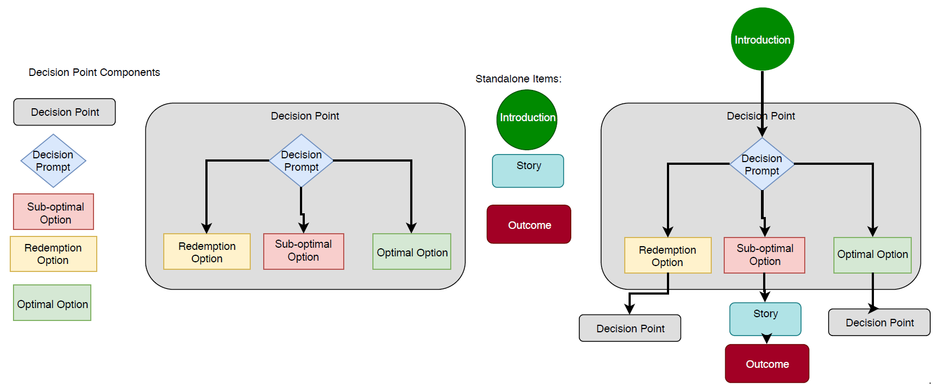
Outcome = the final result based on series of decisions

The Flow Chart depicts the series of decisions that can be made while doing the Critical Thinking Challenge and may be used as an aid to guide students. Each level depicts a decision point. From each decision point stems the optimal and sub-optimal option and, if applicable, a redemption or story point. The outcome is based on the decision made at each level. Depending on the decision, levels may be skipped. Ultimately, the outcome describes the result based on the decisions made throughout the activity.
Note: The purpose of the CTC is to explore different decisions until the student arrives at the best one. Students should reflect on their outcome and what choices they made that led to it. If the outcome is sub-optimal or mediocre, then the student should do the challenge again with the goal of reaching the optimal decision.

Last updated: March 18, 2020

